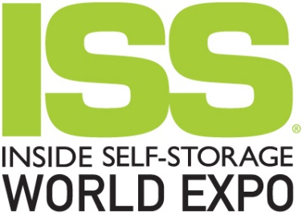
COVER LETTER TO SUPERVISOR

To: < Insert Supervisor name>
Date: < Insert date>

Subject: Attending the 2024 ISS World Expo

I’d like to get your approval to register for the Inside Self-Storage (ISS) World Expo, April 2-5, 2024, where industry professionals will connect for four days of incomparable education, robust networking, product and service exploration, and much more!

There’s no other place where I’ll have the opportunity to learn the key information I need to get the most out of our current (and future) products and technologies. The education program offers 42 seminars covering six education tracks: Big Picture, Building, Innovation, Investing, Management, and Ownership. By attending these insightful sessions, I’ll enhance my efficiency, stimulate my thinking and sharpen my skills.

I’ll also be able to peruse the exhibit hall, where I can identify new products and potential partners that could open new business resources and opportunities. I’ll be able to network with a variety of storage experts and colleagues who face similar challenges.

My goal is to achieve the following three objectives:

• 1:__________________________________________________________________________

• 2:__________________________________________________________________________

• 3:__________________________________________________________________________

I am seeking approval for related expenses. My registration fee would be $<insert amount from worksheet>. Travel-related costs will be approximately $<insert amount from worksheet>.

After returning home, I will have learned the latest industry trends and knowledge, which I can immediately put to use to the benefit of our self-storage operation! Please let me know if you have any questions, and thanks in advance for your support.

Sincerely,
< Insert your name>

